ABSTRACT

"Social media has become an integral part of our daily lives, connecting us with friends, family, and the world at large. In this project, we explore the impact and potential of social media on business and personal branding. We will delve into the workings of popular platforms such as Facebook, Twitter, Google+, YouTube, and LinkedIn, analyzing their unique features and user demographics.

We will examine how businesses can use social media to reach new customers, build brand awareness, and engage with their audience. We will also explore the role of social media in personal branding, and how individuals can use these platforms to showcase their skills, network with others, and build their professional reputation.

We will examine issues such as privacy, security, and the impact of social media on mental health. We will also discuss the importance of creating a social media strategy that aligns with your business or personal goals, and the need to regularly monitor and adjust your approach as the social media landscape evolves.

Whether you're a seasoned social media user or just starting out, this presentation will offer valuable insights into the ever-evolving world of social media.

# Introduction

In the contemporary digital age, social media has emerged as a powerful force, transforming the way individuals communicate, share information, and interact with the world around them. Social media is extremely important and its influence is vast and undeniable.

The significance of social media cannot be overstated. With billions of active users globally, platforms like Facebook, Twitter, Instagram, and TikTok have become essential tools for communication and connectivity. They serve as forums for public discourse, avenues for marketing and brand building, and spaces for social movements and activism. Social media's ability to rapidly disseminate information has made it a critical element in news distribution and a catalyst for social change.

This project aims to delve into the multifaceted world of social media, exploring its origins, development, and the profound impact it has on modern society.

Through a combination of research, case studies, and expert insights, this project will offer a detailed exploration of social media’s dynamics, its benefits, and its pitfalls. Our objective is to equip readers with a nuanced perspective on social media, enabling them to navigate its complexities and leverage its potential while remaining mindful of its limitations.

# Functional Requirements

Functional requirements for a social media project outline the specific behaviours and functionalities the system must exhibit to meet user needs and expectations. These requirements typically define how the system should respond to particular inputs, perform certain tasks, or produce specific outputs. Here are some detailed functional requirements for a social media project:

Feed Display: The platform should display a feed of posts from users that the current user follows.

Search Functionality: Users should be able to search for other users, posts, or hashtags.

Notifications: The platform should send notifications to users about interactions with their posts or other relevant activities.

Privacy Settings: Users should be able to control their privacy settings, such as who can see their posts or send them messages.

Messaging: Users should be able to send private messages to other users.

Reporting: Users should be able to report inappropriate content or users.

Analytics: The platform should provide analytics for users, such as post performance or follower growth.

Integration: The platform should be able to integrate with other social media platforms for cross-posting or account linking.

Accessibility: The platform should be accessible to users with disabilities, following web accessibility guidelines.

Security: The platform should implement security measures to protect user data and prevent unauthorized access.

# Entity-Relationship (ER) Diagram

Let’s represent these entities and their relationships visually using an ER diagram.

**Entities:**

**User:** UserID (primary key), username, email, password.

**Post:** PostID (Primary Key), UserID (Foreign Key), Content, MediaType.

**Comment:** CommentID (Primary Key), PostID (Foreign Key), UserID (Foreign Key), Content.

**Like:** LikeID (Primary Key), PostID (Foreign Key), UserID (Foreign Key).

**Friend:** FriendID (Primary Key), UserID1 (Foreign Key) , Status.

**Message:** MessageID (Primary Key), SenderID (Foreign Key), ReceiverID (Foreign Key), Content.

**Group:** GroupID (Primary Key), GroupName, MemberCount.

**Event:** EventID (Primary Key), EventName, OrganizerID (Foreign Key), Date, Location.

**Notification:** NotificationID (Primary Key), UserID (Foreign Key).

**Advertisement:** AdID (Primary Key), AdTitle, AdContent, AdURL.

**Relationships:**

**One-to-Many Relationships:**

User to Post, User to Comment, User to Like, User to Friend, User to Message, User to Notification, User to Advertisement**.**

**Many-to-Many Relationships:**

User to Group, User to Event, User to Friend.

E-R Diagram:

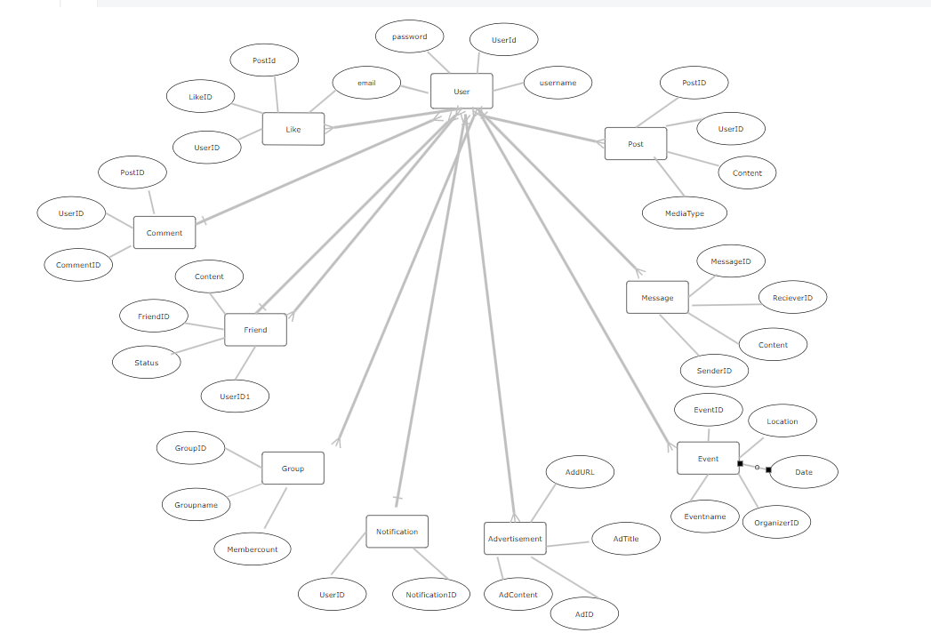

# Queries To Create Database

Creation of database:

* Create database socialmedia;

Creation of tables:

* create table user(userid int(10) primary key,username varchar(25),email varchar(50),password varchar(20));
* create table post(postid int(10) primary key,userid int(10) references user(userid),content varchar(255),media_type varchar(255));
* create table comment(commentid int(10) primary key,postid int(10) NOT NULL references post(postid),userid int(10) NOT NULL references user(userid),content varchar(255));

Inserting values into tables:

* insert into user(userid,username,email,password) values (01,"sravani_19","madhagonisravani@gmail.com","Srav1234");
* insert into post values(101,01,"Breathtaking views like these remind us of the beauty that surrounds us","Nature Photo");
* insert into comment values(201,101,01,"Love this setup! There's nothing like getting lost in a good book with a cup of tea in hand");

Select command:

* select * from post;
* select postid from post;
* select * from post where postid=101;

Alter command:

* alter table user add phonenumber int (11);
* alter table post modify column media_type varchar(25);
* alter table user drop column phonenumber;
* alter table post rename column media_type to mediatype;

Update command:

* update notification SET notification_id =1101 where user_id = 01;
* update message SET content = “Hii”;

Delete command:

* delete from group_s where group_id = 1107;

Drop command:

* drop table advertisement;
* truncate table event;

Commands:

* select count(username) from user where username like “%a”;
* alter table advertisement drop constraint adtitle;

# Class Diagram

# 